## ****Step 1: Calculate X\*Y, X2, and Y2****

First, we’ll calculate the following metrics for each row:

* x\*y
* x2
* y2

The following screenshot shows how to do so:

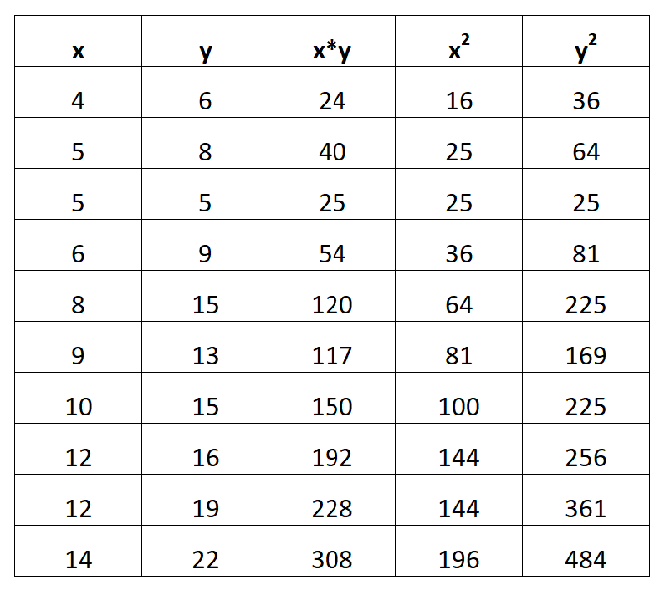

## ****Step 2: Calculate ΣX, ΣY, ΣX\*Y, ΣX2, and ΣY2****

Next, we’ll calculate the sum of each column:

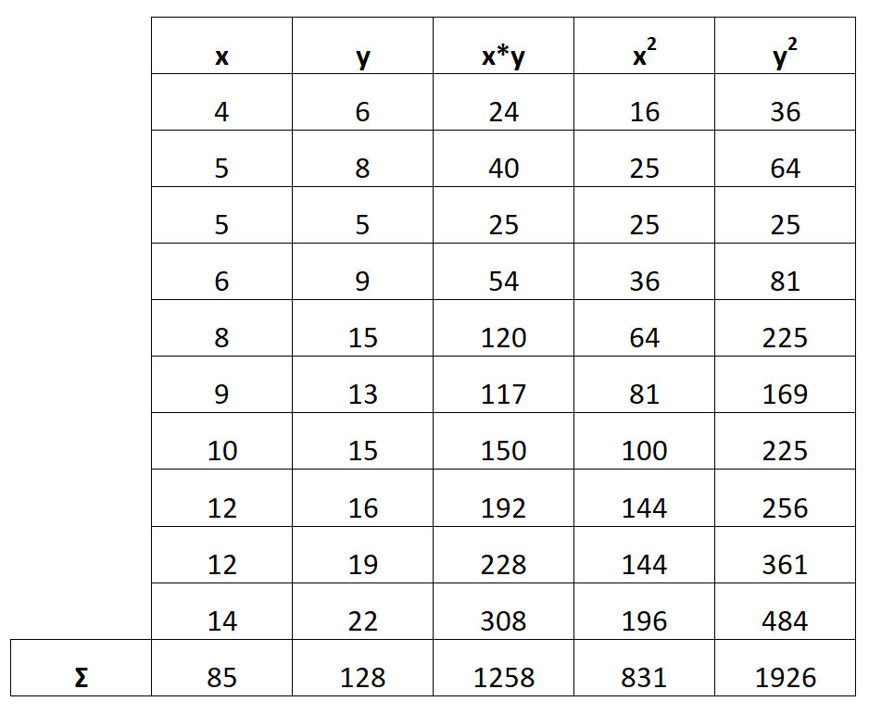

## ****Step 3: Calculate b0****

The formula to calculate the intercept of the regression equation, b0, is as follows:

* b0 = ((Σy)(Σx2) – (Σx)(Σxy))  /  (n(Σx2) – (Σx)2)
* b0 = ((128)(831) – (85)(1258))  /  (10(831) – (85)2)
* ****b0 = -0.518****

****Note****: In the formula, *n* represents the total number of observations. In this example, there were 10 total observations.

## ****Step 4: Calculate b1****

The formula to calculate the slope of the regression equation, b1, is as follows:

IMG_258

* b1 =  (n(Σxy) – (Σx)(Σy))  /  (n(Σx2) – (Σx)2)
* b1 = (10(1258) – (85)(128))  /  (10(831) – (85)2)
* ****b1 = 1.5668****

## ****Step 5: Write Linear Regression Equation****

The final linear regression equation can be written as:

* ****ŷ = b0 + b1x****

IMG_259

Thus, our linear regression equation would be written as:

* ****ŷ = -0.518 + 1.5668x****

We can double check that this answer is correct by plugging in the values from the table into the [Simple Linear Regression Calculator](https://www.statology.org/linear-regression-calculator/" \t "https://www.statology.org/find-linear-regression-equation-from-table/_blank):

